33.19: a) The slower the speed of the wave, the larger the index of refraction—so air has a larger index of refraction than water.
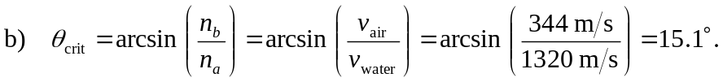
c) Air. For total internal reflection, the wave must go from higher to lower index of refraction—in this case, from air to water.

